* ­­­play with git on the backgrounds

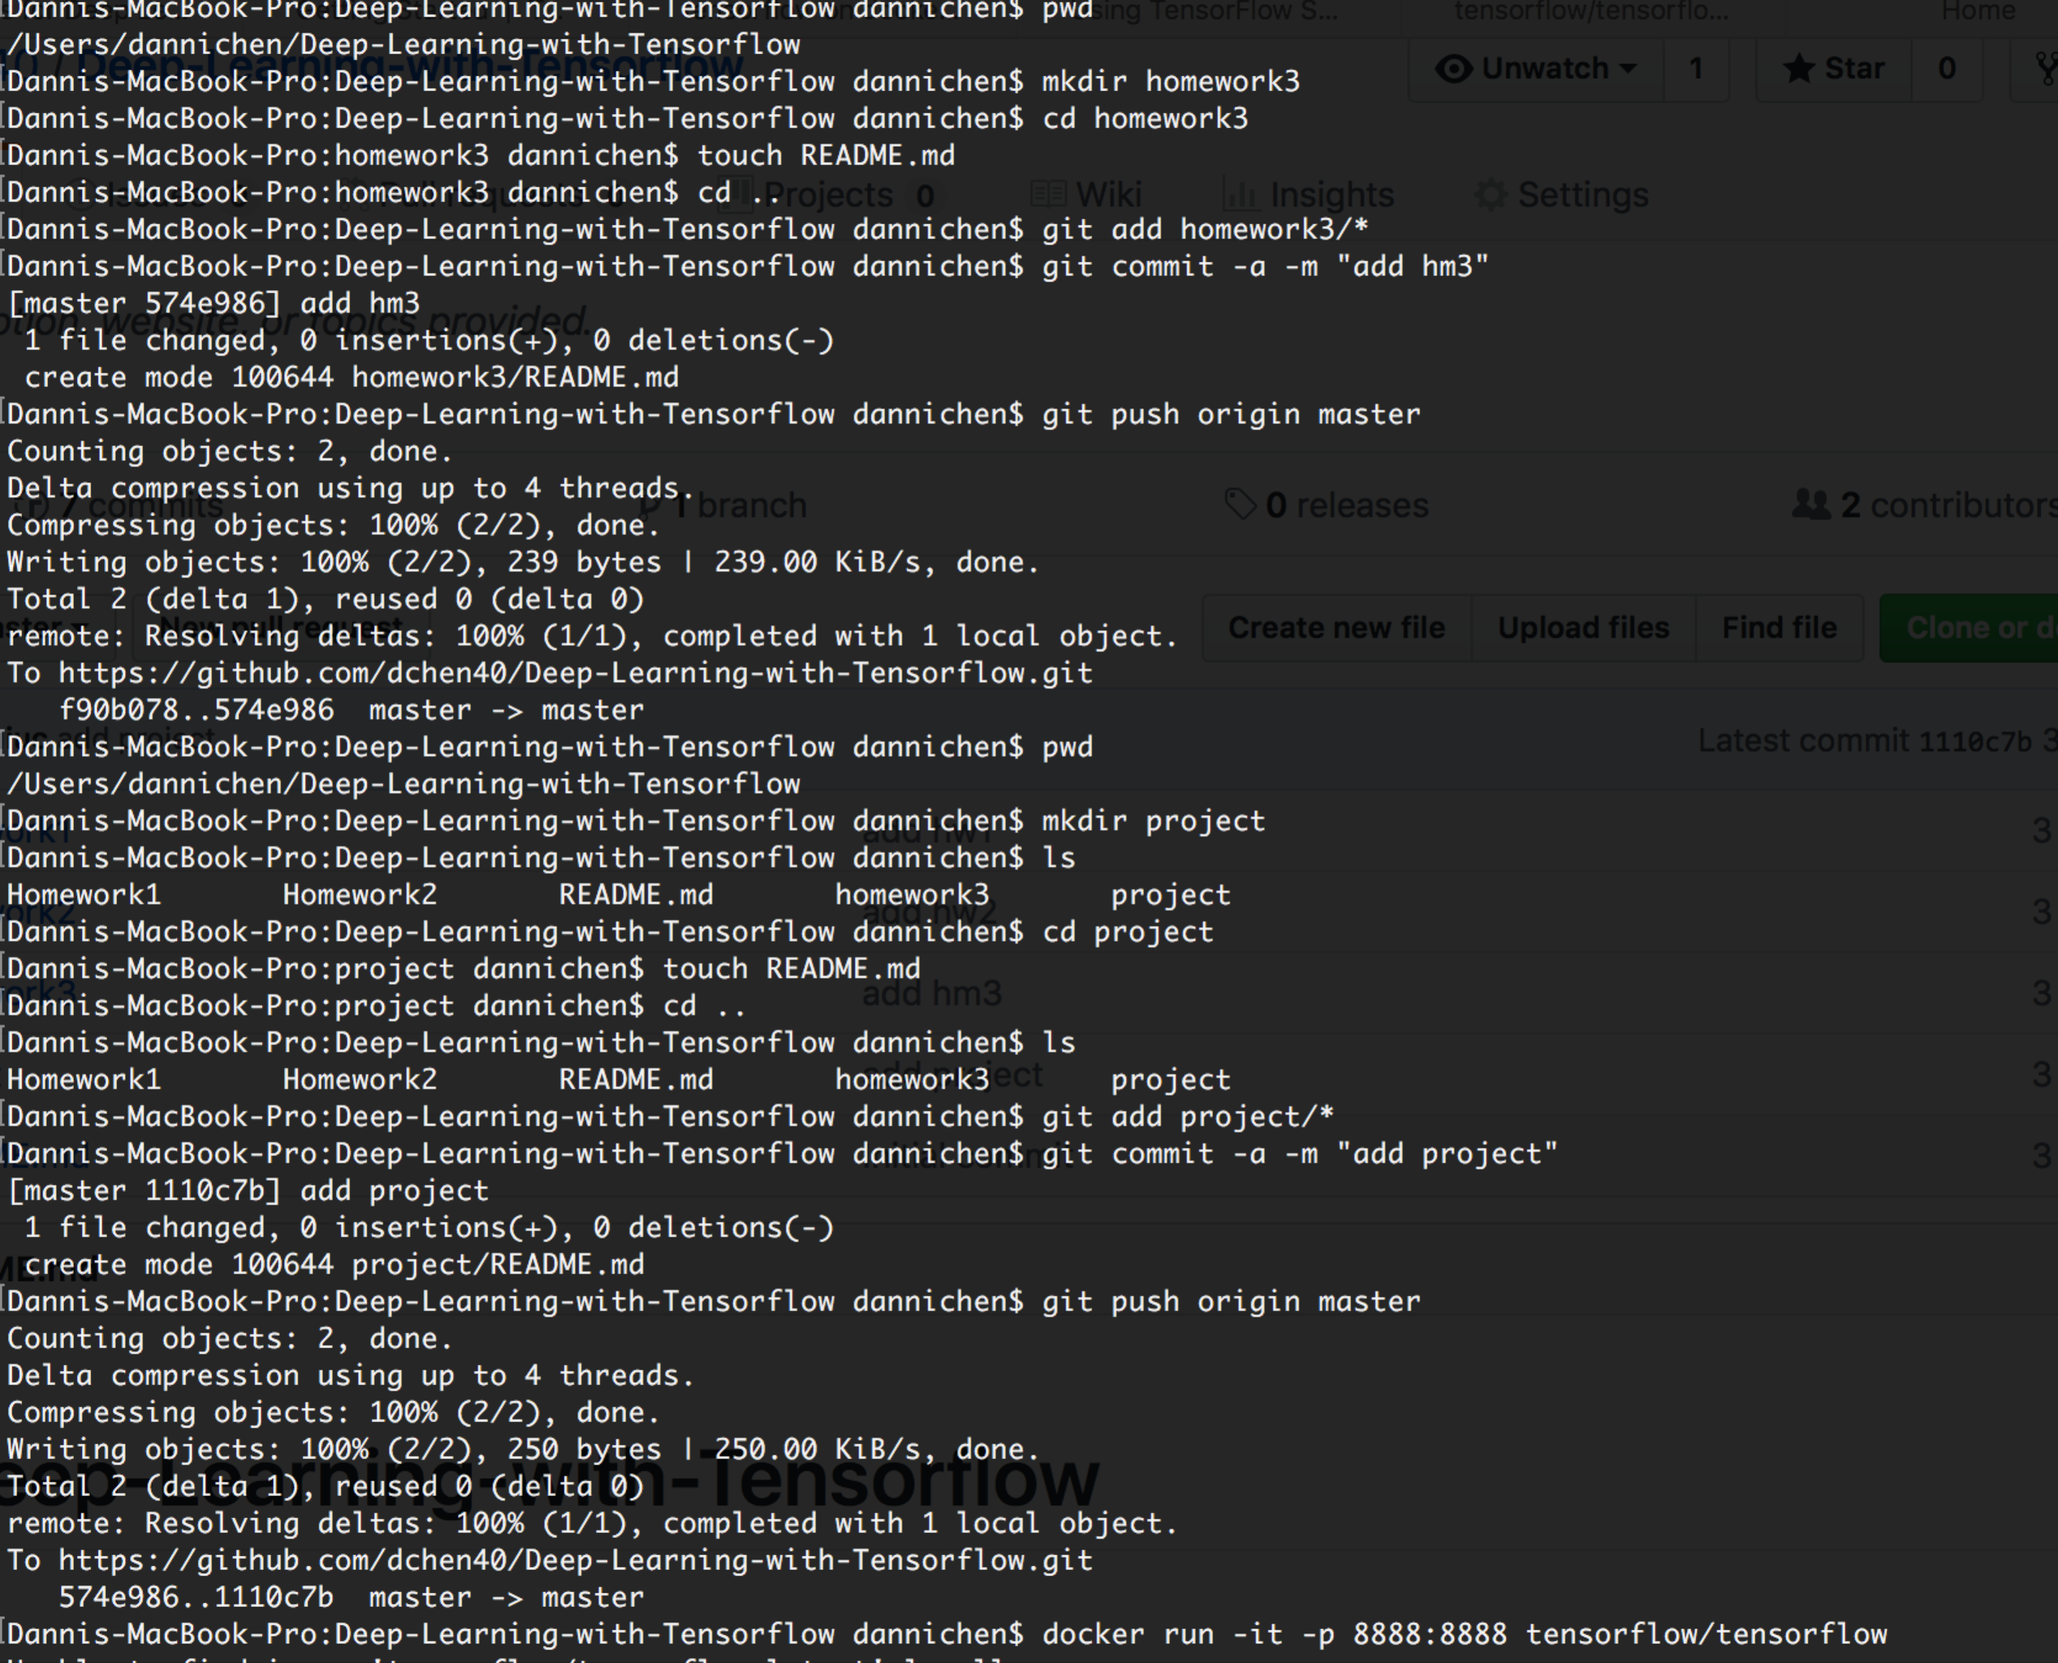

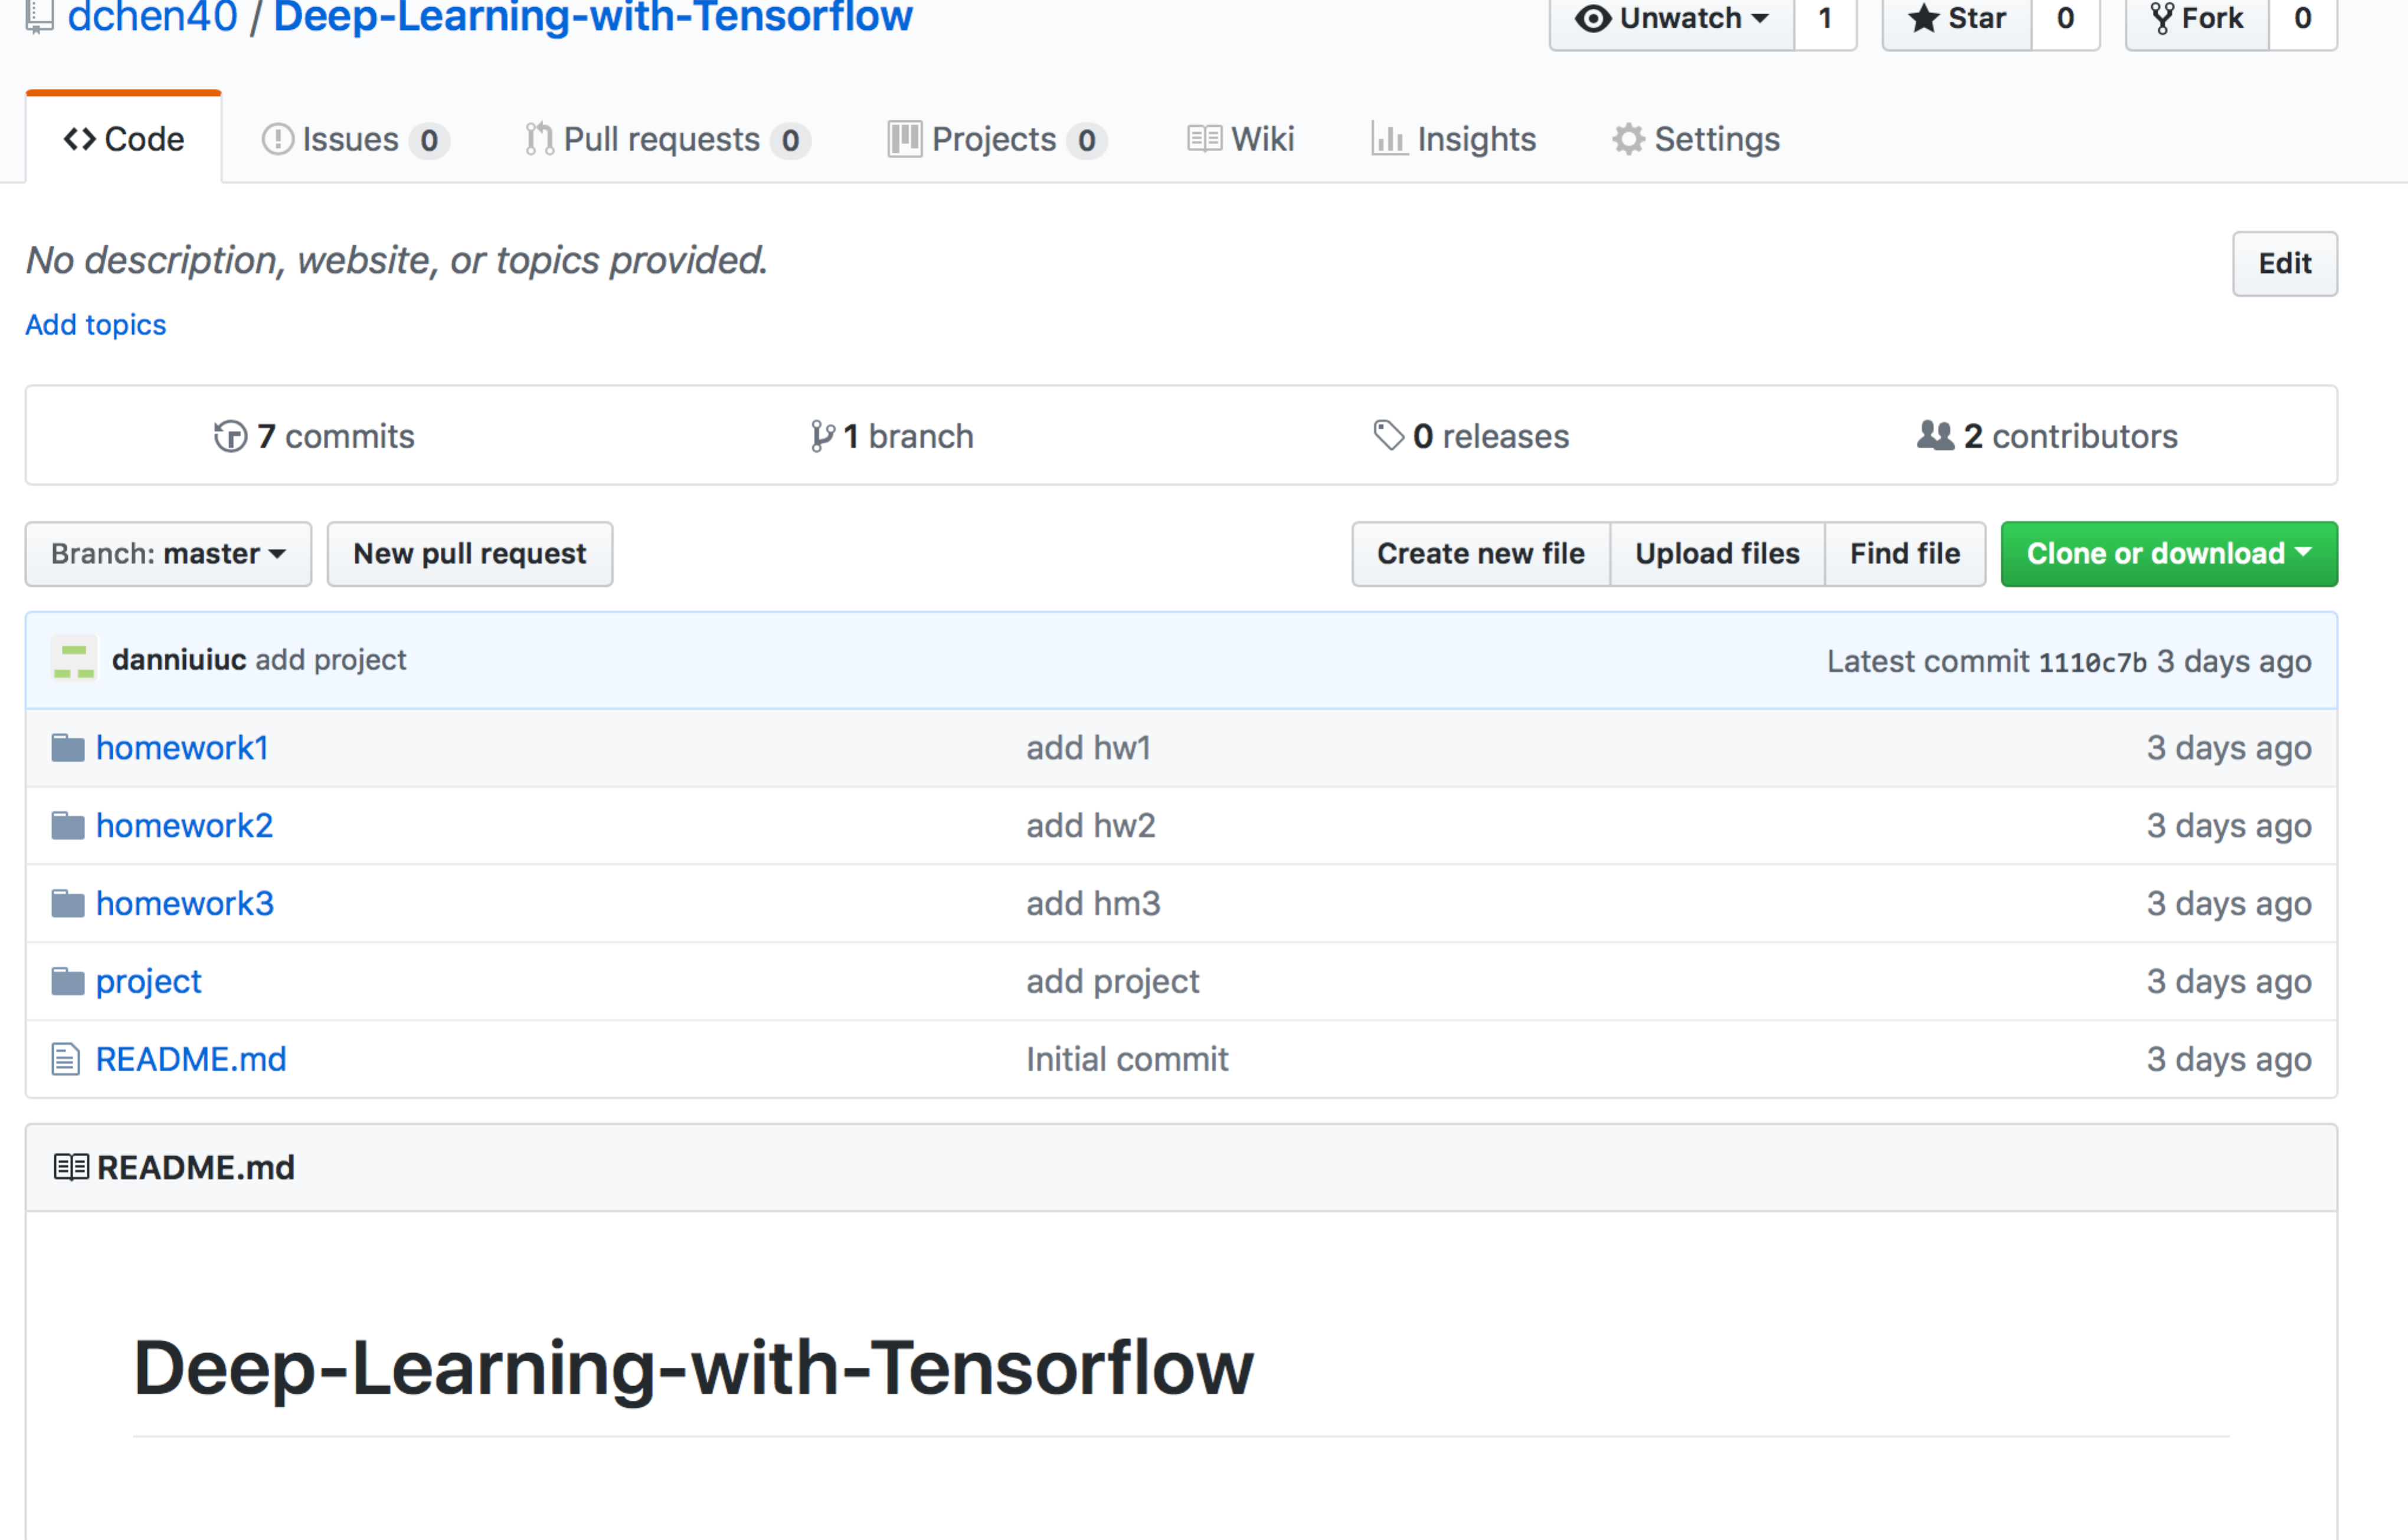

* play with TensorFlow samples by changing numbers in samples

- play with TensorFlow CPU binary image, adding your note

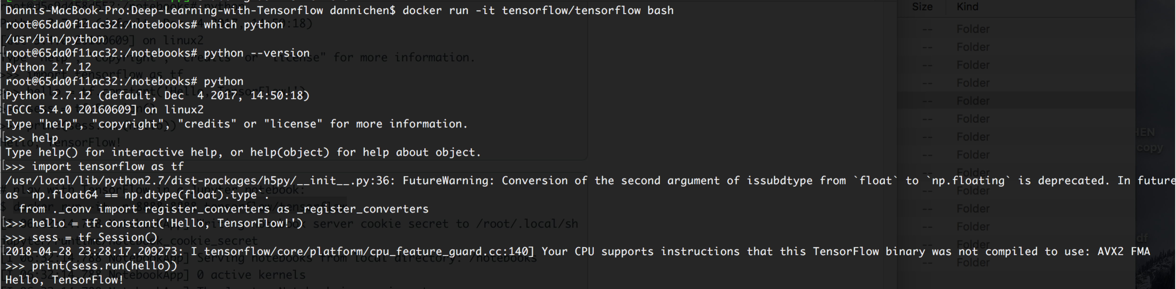

- play with TensorFlow in a Jupyter notebook, adding your notes

